**Basketball**

**Lesson**: 4

|  |  |
| --- | --- |
| **Lesson #:** 4 of 11  **Topic:** BouncePassing for Basketball  **Grade(s):** 4 or 5  **Materials and resources:**   * 9 Basketballs * One cone per person * Two different sets of coloured pinnies. | **Learning objectives (TSWBT):**   * Be able to do a straight bounce pass towards a direct target. |

|  |  |  |
| --- | --- | --- |
| **Parts of the Lesson**  **Set up for me beforehand**:   * Set up cones in places * Place basketballs   **What they have already learnt:**   * Dribbling * Regular chest pass * Done 1 brief lesson of bounce passing. |  |  |
| **Lesson Description:**  Warm-up:   * Arrange all of the students into partners (they can choose or we can choose). * Each pair has one ball. * They will be sent to go find a line on the gym floor with enough space between each partner to pass the ball. * The partners will practice bounce passing the ball to each other on the line for accuracy.   *Psychomotor skills:*   * Catching the ball. * Passing the ball.   *Cognitive skills:*   * Concentration on the ball.   *Affective Skills:*   * Creation of a safe environment within the class. * Partner work to effectively get the ball to the other student.   *Modifications/Alterations:*   * Moving closer or farther apart from each other (based on age/skill level).   Dan’s Ball Game with a twist:   * Arrange the students into groups of 4 and tell them to find a set of 4 cones previously set up.   Refer to diagram 1.   * Designate 1 student to start in the middle (they will be trying to get the ball) and have the other 3 behind one cone each (there will be an extra cone). * 1 student will start with the ball and bounce pass it to another student on the outside of the square while trying to avoid the ball being intercepted by the person in the middle. * The goal of the game is to not let the person in the middle intercept the pass. * If the pass is intercepted then that student is on the outside of the square and the person who passed it is on the inside.   **Rules:**   * The ball can only be passed to someone at a cone next to you, not diagonally across (you can also not run diagonally across to a different cone). * Do not throw the ball hard, we are not trying to hurt the person in the middle. * If the ball leaves the square, just go grab it and start where you were. * Faking a pass is allowed. * Bounce passing only.   *Psychomotor skills:*   * Running * Passing a ball * Catching the ball   *Cognitive skills:*   * Tactical planning for outside people to avoid the person in the middle catching the ball. * Tactical planning for the person on the indie trying to get the ball from the other players.   *Affective skills:*   * Working in a team to keep the ball from getting to the person in the centre.   *Modifications/Alterations:*   * Making the square bigger/smaller (based on age/skill level).   Ball Pass:   * Cones and balls already set up.   Refer to diagram 2.   * Split students off into three even teams. * Each student will stand behind one cone in their team’s area. * One student (student A) will be beside the basketballs placed on the floor. * Student A Will grab one of the basketballs laying next to them and hold it until the teacher says GO. * They will bounce pass the ball to the student Diagonal to them (Student B). * Student B will then bounce pass the ball to the student diagonally ahead of them (student C). * Once student B has passed the ball to student C and is ready to receive a pass (making eye contact and saying the next student’s name) student A will pass the next ball to student B. * As each ball reaches the final student, that student will place the ball on the ground next to them. * The first team with all of their balls with the final student will win.   **Rules:**   * No student will touch the basketballs until the teacher allows it. * Each student must make eye contact with the student they are passing to. * No interfering with other teams balls. * Must stay at your cone throughout the game. * If you lose the ball go get it and return to your cone, the person that comes before the one who lost the ball will need to wait to pass the next ball until they get back. * All passes must be bounce passes.   *Psychomotor skills:*   * Passing the ball * Catching the ball   *Cognitive skills:*   * Hand-eye coordination * Quick reactions   *Affective skills:*   * Team work using communication to get the ball to each student   *Modifications/Alterations:*   * Moving the students closer/farther apart. * Making more/less groups. * Adjusting the amount of balls used. * Changing the rules so if a ball is dropped or missed then they have to restart that ball from the beginning.   End Zones   * Divide the class into 3 teams. * Have a designated end zone at each end of the gym for each team marked by a specific line or cones. * Two of the teams will wear pinnies that are different in colour from each other. * Two teams will start on the court (1 team will be sitting off). * In the game, each team is trying to get the ball into the other team’s end zone to gain points (one point each time the ball reaches the end zone, similar to football). * After a predetermined amount of time the game will end and the winner will be declared. * The team that was sitting off will then play one of the team’s that was on and this will repeat until each team has played 3 games.   **Rules:**   * Only bounce passes and dribbling allowed. * The ball must be in the hands of a person in the end zone to gain a point. * The ball must be passed to a minimum of 4 different people before trying to gain a point.   *Psychomotor skills:*   * Running * Passing the ball * Receiving the ball * Dribbling   *Cognitive skills:*   * Tactical thinking to avoiding letting the other team get the ball * Tactical thinking for how to get the ball from the other team * Organizing strategies   Affective skills:   * Teamwork to try and get more points than the other team.   *Modifications/Alterations:*   * Allowing a chest pass. * Not allowing dribbling or so they can only take a certain number of steps. * Making the boundaries bigger/smaller. * Adjusting the number of passes/people to touch the ball required. | 5 mins.  10 mins.  15 mins.  15 mins. | **Teaching points**   * Aim the ball for the line. * Aim to bounce the ball three-quarters of the way between you and your partner. * Have hands up ready to catch the ball. * Communication. * Have hands up ready to catch the ball. * Move to empty cones. * Team building. * Team Building * Communication * Passing the ball quickly and accurately * Receiving the ball * Team building * Accuracy * Communication * Receiving the ball * Passing the ball * Dribbling * Moving into empty space |

Diagram 1: (other students will be placed into the blank sections of the gym)

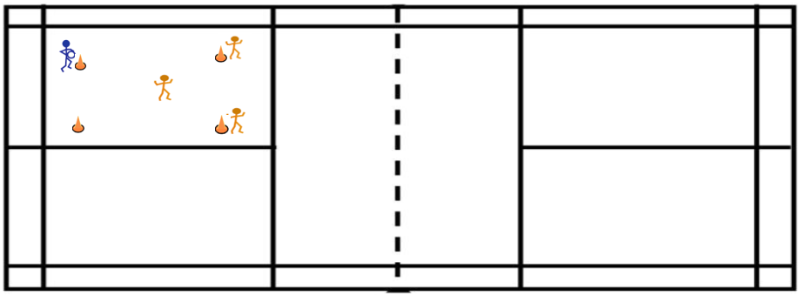

Diagram 2: (There would be two other teams in the blank areas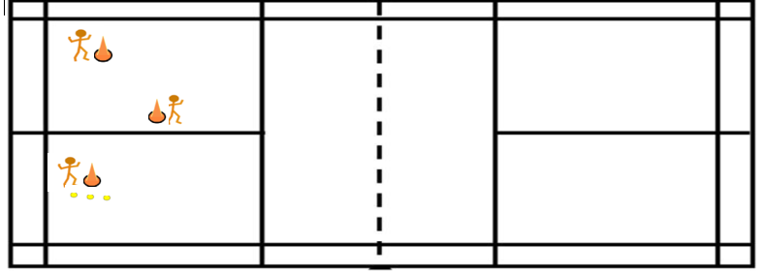

Diagram 3: (This would be the full length of the gym)

